SHAHNAZ FATHIMA .N

230701302

**UID ASSIGNMENT – 5**

**TASK ANALYSIS AND USER FLOW USING LUCIDCHART**

This document explains the user flow for an e-commerce website, detailing each step in the shopping process. The diagram visually represents user interactions from website entry to checkout and order confirmation. Different shapes indicate processes, decisions, and endpoints to ensure a clear understanding of the workflow.

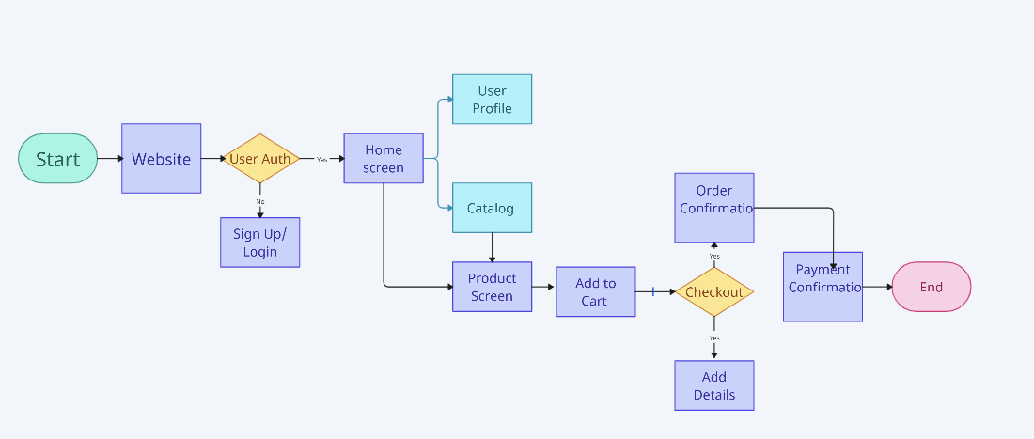

**Shapes and Their Meanings**

* **Ovals (Start, End):** Represent the beginning and end of the process.
* **Rectangles (Processes):** Represent actions such as visiting the website, home screen navigation, and order confirmation.
* **Diamonds (Decisions):** Represent decision-making points, such as user authentication and checkout.
* **Arrows:** Show the logical flow from one step to another.

#### ****User Flow Explanation****

##### **Step 1: Website Entry (Start)**

* The user begins their journey at the website entry point.
* They navigate to the main website page to explore products or log in to their account.

##### **Step 2: User Authentication**

* A decision point determines whether the user is authenticated.
* If the user is already logged in, they proceed to the home screen.
* If not, they are redirected to the Sign-Up/Login page to enter credentials.
* Upon successful login, they return to the home screen.

##### **Step 3: Home Screen Navigation**

* From the home screen, users have access to two main areas:
  + **User Profile:** Allows users to manage personal information, order history, and preferences.
  + **Product Catalog:** Displays various products for browsing.

##### **Step 4: Product Exploration and Selection**

* Users navigate the catalog to explore different product categories.
* Clicking on a product redirects them to the product detail screen.
* Users can review product descriptions, images, pricing, and availability.

##### **Step 5: Adding Items to Cart**

* After selecting a product, users can add it to their cart.
* They can continue shopping or proceed to checkout.

##### **Step 6: Checkout Process**

* A decision point checks if the user is ready for checkout.
* If additional details are required (such as shipping information), users enter them before proceeding.
* If all necessary information is already available, they move directly to order confirmation.

##### **Step 7: Payment Confirmation**

* The user completes payment through the selected payment method.
* If the payment is successful, the order is confirmed.
* If the payment fails, users may need to retry or update payment details.

##### **Step 8: Order Confirmation (End)**

* Once payment is verified, users receive an order confirmation.
* The process ends here, ensuring a seamless shopping experience.